Renju lesson on April 12, 2001

Hello all! Welcome to Online Renju Class. Today we will continue with d11 opening.
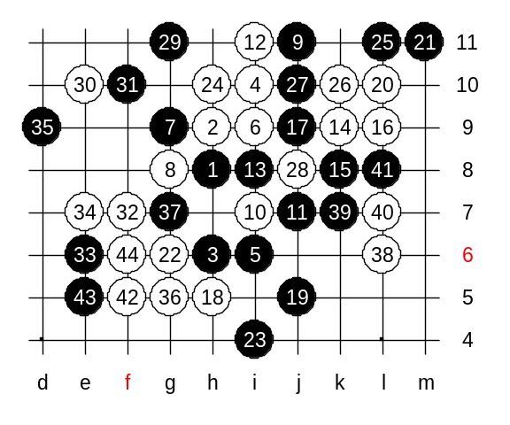
Today we will learn the correct 10th move in the main variant. You all know it. Now we are getting to the hardest part. It is the decision how to handle this opening as black. There are some 11th moves possible. Which 11th moves have you used before? As you all know, the 11-i8 was surely the most popular move in past years. And even now, people play it every day. In fact, 11-i8 is the only move that gives black the initiative. Other 11th moves either give white win or white advantage. Lets learn about them first. 11-j7, an old gambling move. If you havent read books or seen games about it, then you most likely don’t find the win here. How many of you know the white attack here? I loved this variant when I was younger, because the ideas of white attack fascinated me. The first idea is to make development move. Since black has some material below, black must develop by either using a control style or keep VCF threats all the time. If we go j9 then black L9, white k8, black h11, and the outcome is questionable. We must play i11 and then k9. Do you know why white didn’t use the four to i13 first? The reason is – never use a four unless you have to. What happens if you don’t use four? The only concern is if black goes L9. But the the white goes k8 and wins easily because all black material is controlled by white, and white has enough lines to win in few moves. Shineyes asks, did we have to play i11 before k9. The same reason. I played it only because I had to. What would have happened if I didn’t play i11 first? Yes, otherwise black can take i11 point.
Lets go on. Does white have VCF threat now? Black’s 15-k8 is the only move that doesn’t lose immediately. White L9 now. We already learned how to set up the first attacking material by keeping the VCF threat at L9 point. Now the next step is to develop more by giving pressure on 4x4 point. But.. there is small question. Black has VCF threat now, you all see it right? So, now it is time to make important balancing move. H5. Look at the position in general. White has a big advantage and promising space on the left and upper side. Black cannot survive with passive play here. Black has to do something or die anyway soon. Agree? So black goes to last desperate attack. 19-j5 – an interesting move. Now we come to the 3rd part of the white development. It is the conquer about the initiative. Black wants to win, so does white. L10 ! – good timing. G6 now – white creates VCF threat, trying to get the tempo. Black i4 – a counter VCF threat. Do you all see black VCF? White has to block that VCF. H10 is the only move that creates blocking cut line for black’s VCF and also creates white’s own threat. SO, black is in agony now. The war for tempo is over. Black is going to deep defense now. Finally, white played on the left side first – e10. Note that e10 is not simply development, but also a VCF threat. Did white actually need that VCF threat? Could white develop softly without having VCF threats all the time? Indeed, black is too active below, so we cannot develop softly. Now we come tot he 4th stage of the development – the final winning attack.
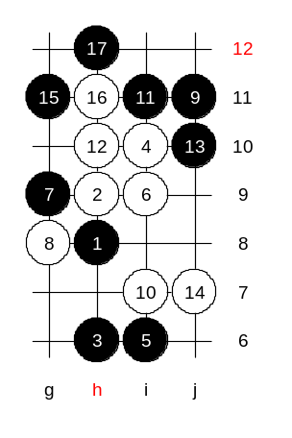

We have completed the discussion about 11-j7.
11-i11 was quite popular move in the past. In most case, white either wins here or gets good advantage.
This is the medium level homework. Please find the white win here.

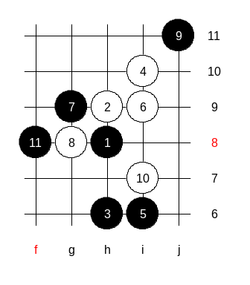

This is the advanced level homework.
Please find white win. Maybe the win does not exist, but give your best try to find it.

